Homework 1

1. (SELF ASSESSMENT) Consider the arbitrary signal f[x], with k = 1 to N observations, and a linear signal model v[x] = αx + β, with α & β being constants to be determined so that v[x] fits f[x] in the least squares sense i.e. min | (v[x]– f[x])2 | = 0.

- Please draw up what you understand is the Linear Time Invariant Systems Block-diagram Model view of this problem, wherein the System is defined as the v[x] = αx + β linear signal model.

f(x)
α
β
v(x)

- Write down the algebraic matrix formulation of this fitting problem, starting with a system of equations defining the fitting problem, given the linear signal model and the N observations. Note that this Linear Algebra / Matrix form of the system is the form which will help you solve for the parameters of the System i.e. α & β, and should something like A k = v, where k = [α, β]T , elaborating on the contents of each term, assuming “N” discrete observations / recordings i.e. (xk, f[xk]) for k = 1 to N.
$$\overline{y}=Ax$$Where,
$$A= \left(\begin{matrix}x_{k} & 1 \\ ⋮ & ⋮ \\ x_{n} & 1\end{matrix}\right), x=\left(\begin{matrix}α \\ β\end{matrix}\right),$$

- Write a Matlab program to compute the least squares fit of the model to the data stored in the i.e. ‘HW1_Q1.mat' contains a signal (data stored in the variable 'f' such that the data constitutes, (xk, f[xk]) data-points for fitting), assuming that A\b in Matlab solves the least-squares fitting problem. Plot the raw data as well as the best fit line, v[x] = αx + β found (overlaid on top of each other). Remember to upload your code through Blackboard.
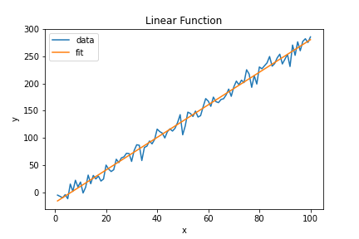

- Compare your solution to the fitting problem using A\b in Matlab to the solution for x = (ATA)-1 AT b. Note that here “-1” indicates the inverse operator and “T” indicates the matrix transpose. Plot the best fit line, v[x] = αx + β, and compare it against the solution obtained in part (a). Note that as per rules of matrix multiplication, (ATA)-1 AT b must be evaluated by multiplying matrices from “right to left” i.e. first compute b1 = AT b and then multiply the result with (ATA)-1 b1.

- (SELF ASSESSMENT) Repeat problem 1a to 1c but now instead considering a quadratic model v[x] = αx2 + βx + γ, with α, β and γ being constants to be determined so that v[x] fits f[x] in the least squares sense i.e. min | (v[x] – f[x]) 2 | = 0. You may just use the “x = A\b” concept in Matlab to solve this system and submit your code and a screenshot of the final fitted model plotted over the scatter plot of the given (xk, f[xk]) data.
  - We can define this equation as follows:

gamma
f(x)
α
β
v(x)

$$\overline{y}=Ax$$Where,
$$A= \left(\begin{matrix}x_{k}^{2} & x_{k} & 1 \\ ⋮ & ⋮ & ⋮ \\ x_{n}^{2} & x_{n} & 1\end{matrix}\right), x=\left(\begin{aligned}\begin{matrix}α \\ β\end{matrix} \\ γ\end{aligned}\right),$$

  - Plots: 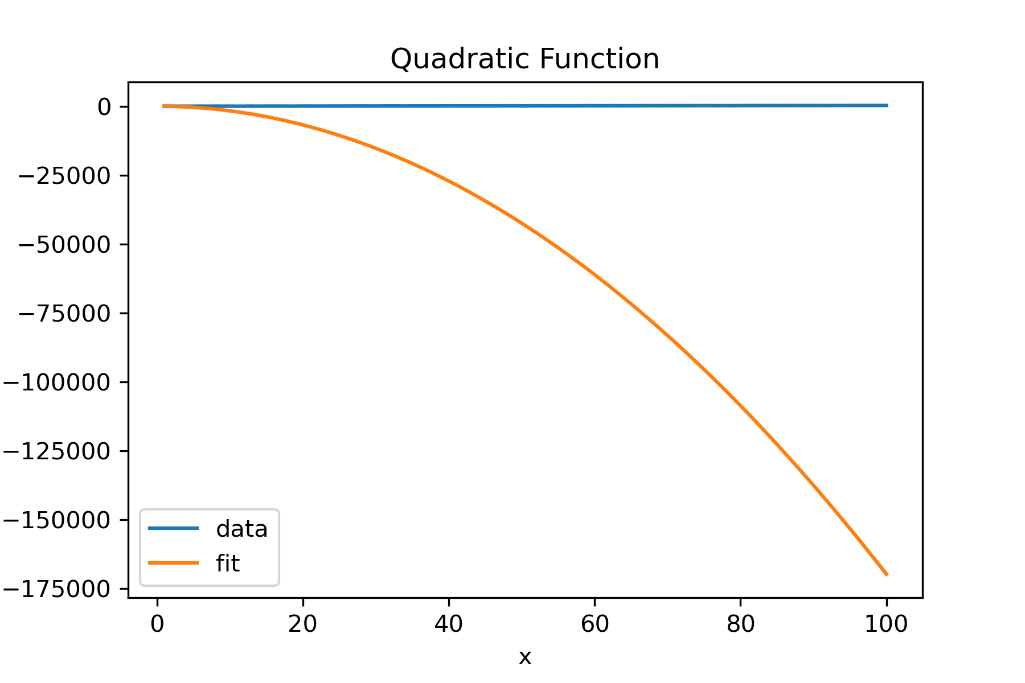
Clearly there’s an issue with the fit here.

- (50 points) For a linear fitting problem, show that (ATA) x = AT b has an algebraic equivalent which can derived from the sum of least-squares minimization problem, given N data points of (xk, f[xk]) i.e. k = 1 to N, to minimize a functional Q[x] to zero, where Q[x] is given by the following:

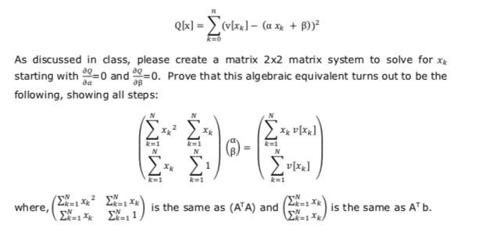
To start we will find the partial derivatives of Q[x] with respect to both alpha and beta algebraically.
Worked with Lenard Watson;
Abish Pius
First,
S1. Partial with Respect to alpha
$$\frac{∂Q}{∂α}=\sum_{k=1}^{n}{2\left(v\left(x_{k}\right)-\left(αx_{k}+β\right)\right) ⋅ {-x}_{k}}=0$$
S2. Divide out the 2 from both sides$$\frac{∂Q}{∂α}=\sum_{k=1}^{n}{\frac{2\left(v\left(x_{k}\right)-\left(αx_{k}+β\right)\right) ⋅ {-x}_{k}}{2}}=\frac{0}{2} \\ \frac{∂Q}{∂α}=\sum_{k=1}^{n}{\left(v\left(x_{k}\right)-\left(αx_{k}+β\right)\right) ⋅ {-x}_{k}}=0$$

S3. Distribute the -x_k $$\frac{∂Q}{∂α}=\sum_{k=1}^{n}{-x_{k}v\left(x_{k}\right)+αx_{k}^{2}+βx_{k}}=0$$
S4. Distribute the Sum$$\frac{∂Q}{∂α}=\sum_{k=1}^{n}{αx_{k}^{2}+\sum_{k=1}^{n}{βx_{k}}}= \sum_{k=1}^{n}{x_{k}v\left(x_{k}\right)}$$

S5. Matrix form: This final for can be rewritten as the follow,
$$\left(\begin{matrix}\sum_{k=1}^{n}{x_{k}^{2}} & \sum_{k=1}^{n}{x_{k}}\end{matrix}\right)= \left(\sum_{k=1}^{n}{x_{k}v\left(x_{k}\right)}\right)$$
As we will see this will be the beginning of our final matrix shown in the introduction of the problem.
Now we will find the partial with Respect to beta,
S6. Partial with Respect to beta
$$\frac{∂Q}{∂β}=\sum_{k=1}^{n}{2\left(v\left(x_{k}\right)-\left(αx_{k}+β\right)\right) ⋅ -1}=0$$
S7. Divide out the 2 from both sides
$$\frac{∂Q}{∂α}=\sum_{k=1}^{n}{\frac{2\left(v\left(x_{k}\right)-\left(αx_{k}+β\right)\right) ⋅ -1}{2}}=\frac{0}{2} \\ \frac{∂Q}{∂α}=\sum_{k=1}^{n}{\left(v\left(x_{k}\right)-\left(αx_{k}+β\right)\right) ⋅ -1}=0$$

S8. Distribute the -1 $$\frac{∂Q}{∂α}=\sum_{k=1}^{n}{-v\left(x_{k}\right)+αx_{k}+βx_{k}}=0$$
S9. Distribute the Sum$$\frac{∂Q}{∂α}=\sum_{k=1}^{n}{αx_{k}+\sum_{k=1}^{n}{βx_{k}}}= \sum_{k=1}^{n}{v\left(x_{k}\right)}$$

S10. Matrix form: Now we add this to our description of for alpha to get the follow final matrix form.
$$\left(\begin{matrix}\sum_{k=1}^{n}{x_{k}^{2}} & \sum_{k=1}^{n}{x_{k}} \\ \sum_{k=1}^{n}{x_{k}} & 1\end{matrix}\right)= \left(\begin{aligned}\sum_{k=1}^{n}{x_{k}v\left(x_{k}\right)} \\ \sum_{k=1}^{n}{v\left(x_{k}\right)}\end{aligned}\right)$$
We can show the following regarding the same process described through matrix algebra,
Where,
$$A= \left(\begin{matrix}x_{k} & 1 \\ ⋮ & ⋮ \\ xn & 1\end{matrix}\right) , x= \left(\begin{matrix}α \\ β\end{matrix}\right), y= \left(\begin{matrix}v\left(x_{k}\right) \\ ⋮ \\ v\left(x_{n}\right)\end{matrix}\right)$$
And we can say,
$$Ax=y$$

Or, when we substract both sides by y to get our difference or residual, R,
$$R = Ax-y$$

In this case we would like to find and minimize the L2 norm, which is the squared residual, R,

$$min⁡({\left\|R\right\|}_{2})$$

To do this we can say that the L2 norm would be,

$${{\left\|R\right\|}_{2}=\left(Ax-y\right)}^{2}$$
So to minimize we can take the derivative with respect to x at 0,

$$\frac{d}{dx}\left({\left(Ax-y\right)}^{'}(Ax-y\right))=0$$
We can distribute the transpose,

$$\frac{d}{dx}\left(\left(A'x'-y'\right)(Ax-y\right))=0$$

We can multiple these factors,

$$\frac{d}{dx}\left(x^{'}A^{'}Ax-x^{'}A^{'}y-y^{'}Ax+y'y\right)=0$$

Now we just evaluate the derivative,

$$\frac{d}{dx}= A'Ax-A^{'}y=0$$

Finally, we can move the -A’y term over to the right-hand side of the equation to get our final form,

$$A^{'}Ax=A^{'}y$$

